鮭のお話

別資料

2015

**サケの一生～母川回帰**

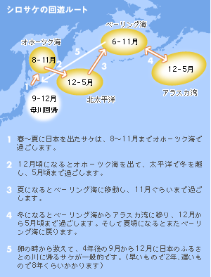

**母川に近づくにつれての鮭の体色の変化**

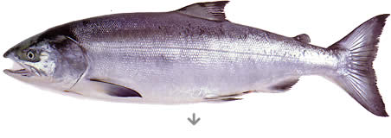

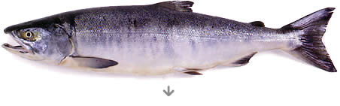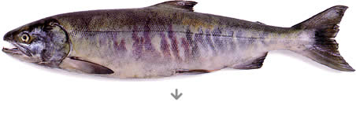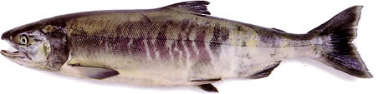

**鮭の利用法**

|  |  |  |
| --- | --- | --- |
|  | http://www.maruha-nichiro.co.jp/salmon/food/images/food04_ph01.jpg | http://www.maruha-nichiro.co.jp/salmon/food/images/food04_ph07.jpg |

|  |  |
| --- | --- |
|  | http://www.maruha-nichiro.co.jp/salmon/food/images/food04_ph02.jpg |
|  | http://www.maruha-nichiro.co.jp/salmon/food/images/food04_ph03.jpg |

|  |  |  |
| --- | --- | --- |
|  | http://www.maruha-nichiro.co.jp/salmon/food/images/food04_ph04.gif | http://www.maruha-nichiro.co.jp/salmon/food/images/food04_ph06.gif |
|  |  |  |

|  |
| --- |
|  |

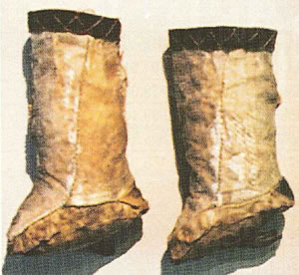

鮭皮で作った靴（ケリ）

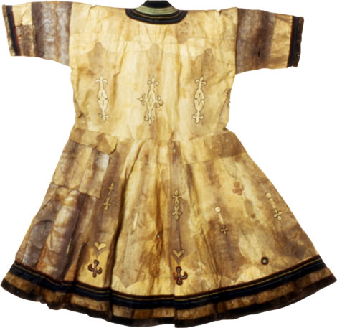

鮭皮の衣装（魚皮衣）

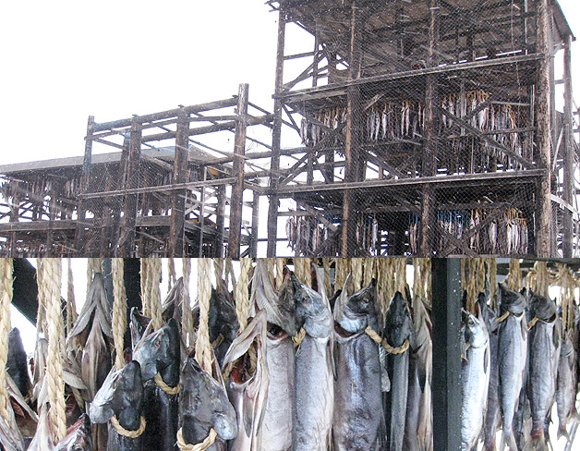

北海道産干鮭

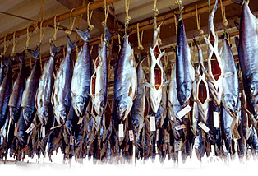

越後村上産塩引き鮭

（MEMO）